*Volunteers will be interviewed in person at the Department of Corrections APP Offices. The interview will take approximately one hour.*

*Benefits of participation include contributing to the research on the effectiveness of intervention programs. Volunteers will also be compensated with a $15 gift card for their time and trouble.*

For more information please contact Katrina Riley: [katrina_riley@hotmail.com](mailto:katrina_riley@hotmail.com) or 385-227-3528

### Eligible volunteers include anyone between the ages of 18-70 that have been or is currently participating in a community based batterer intervention program.

The purpose of this study is to determine which needs are not being met for those that have entered a batterer intervention program.

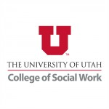

## Eligibility:

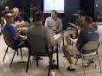

Volunteers needed for research about the effectiveness of batterer intervention programs